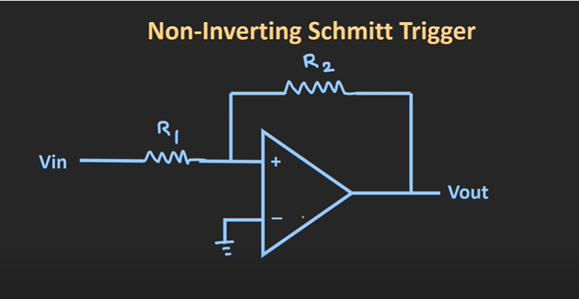

The schmitted trigger is the amplifier which has the function to make the output into the square wave. It means that when Vin is larger than 0, the voltage will be upper voltage, when the Vin is lower than 0, the voltage will the lower voltage.There is a positive feedback from the Vout to the Vin. From the graph, the design we used is OP747.The basic principle of this circuit is mostly the same as the op-amp.(the V+ is the same as the V-).The features of these parts are upper and lower limit. The lower limit can be expressed as V1 = (R1/R1+R2)\*Vin + (R1/R1+R2)\*VL. Therefore, the the lower limit is -R1/R2 \* VL , The upper limit is -R1/R2 \*Vh.